**How to create a first and lasting impression**

**Learning Objectives:**

* How to Avoid Common Body Language Mistakes
* Positive and Negative Body Language
* Frameworks and Important Scenarios
* Daily tips to build positive Body Language

**How to Avoid Common Body Language Mistakes**

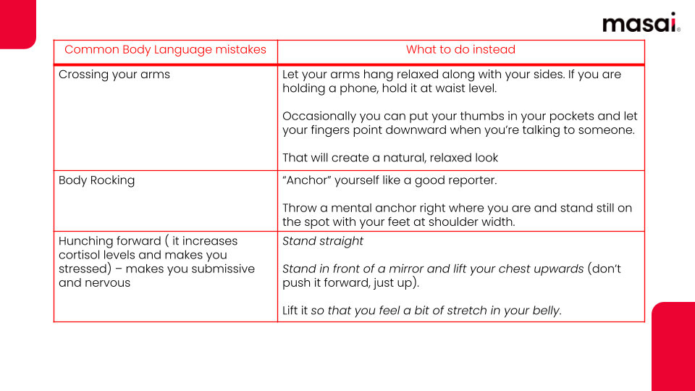

**Positive and Negative Body Language**

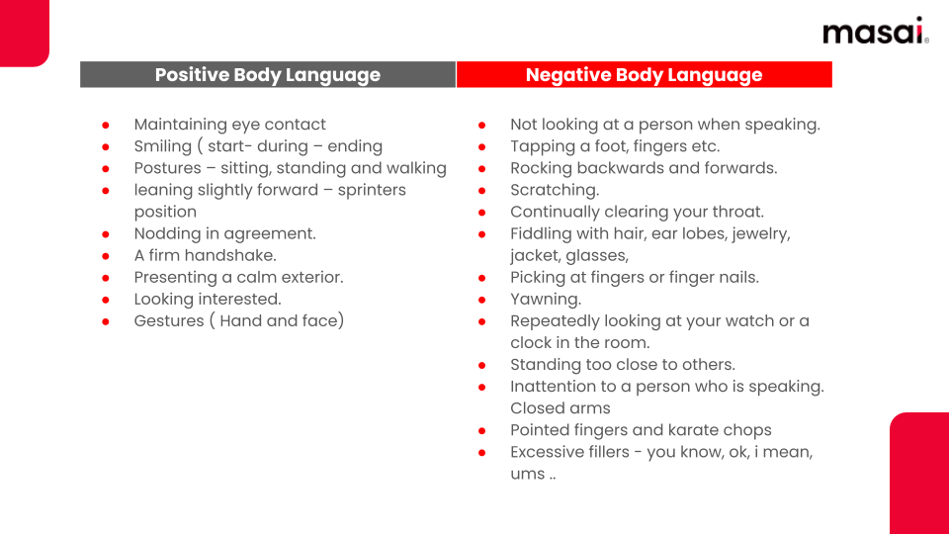

**Frameworks and Important Scenarios**

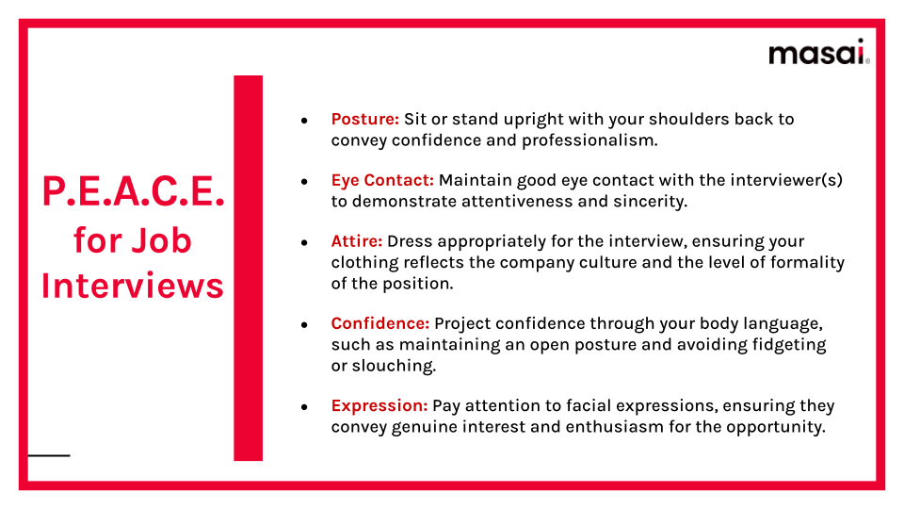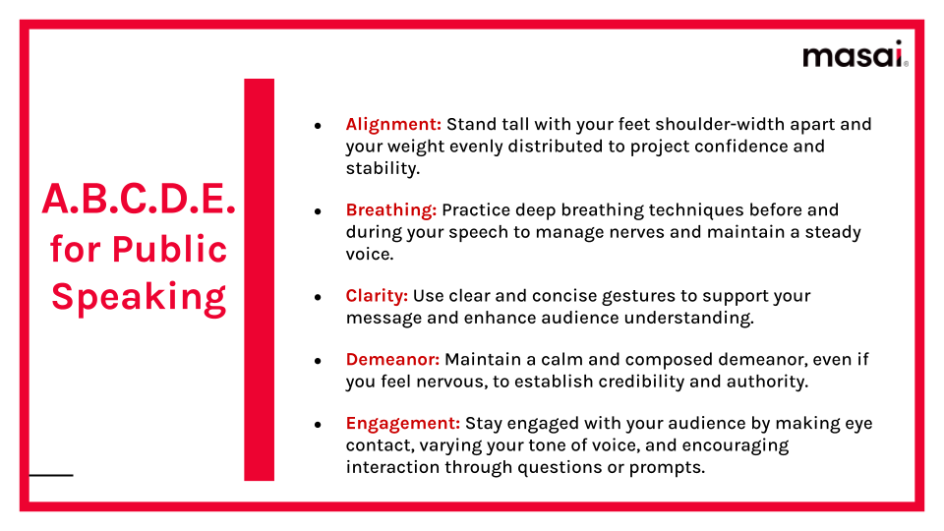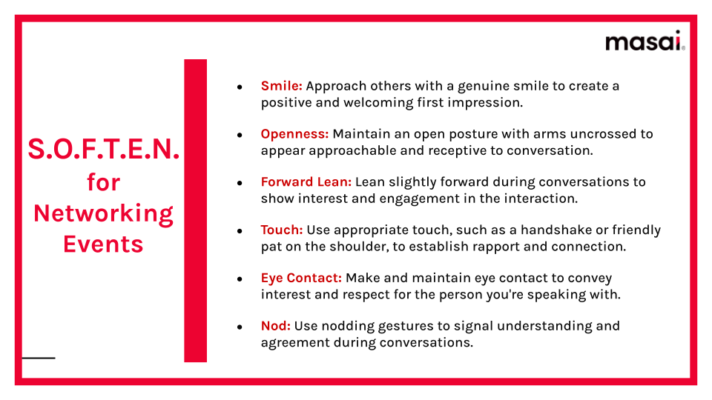

**Daily tips to build Positive Body Language**

